**RESTAURANT SCREEN FEATURES**

1. **Scroll across to search food in the following categories (with ability to add or change food categories as needed):**

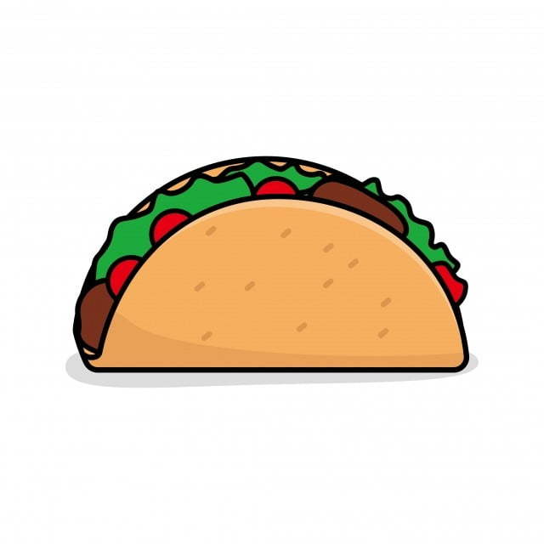

TACO



PIZZA



SMOOTHIE

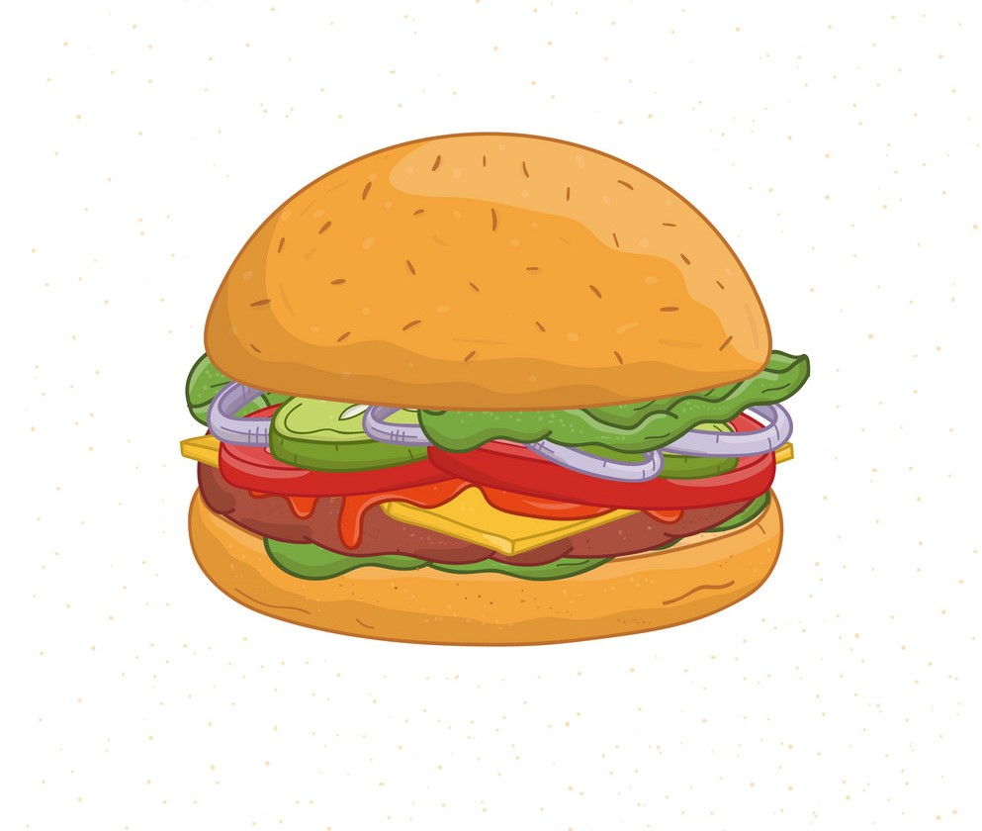

BURGER



DESSERT

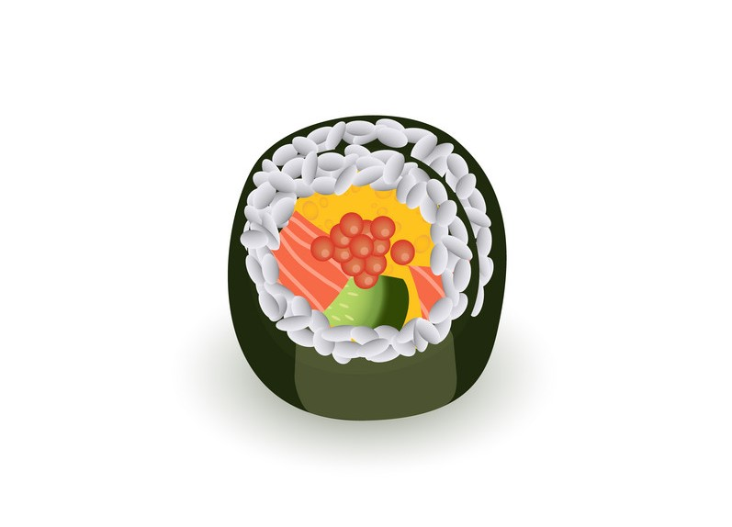

SUSHI

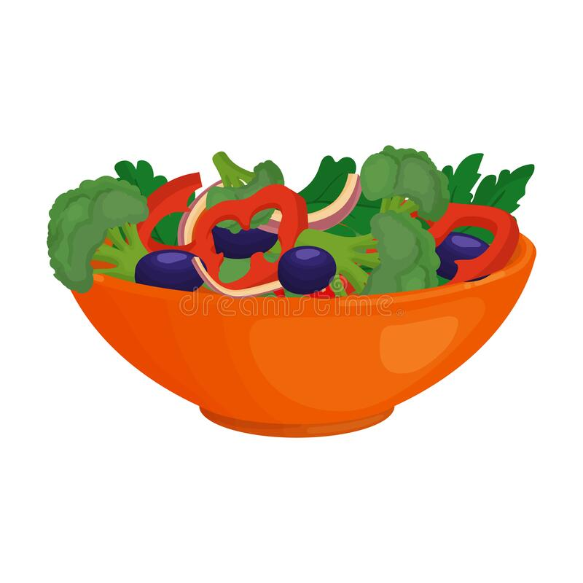

SALAD

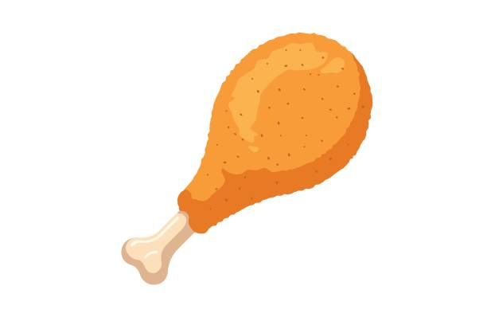

CHICKEN



ICE CREAM

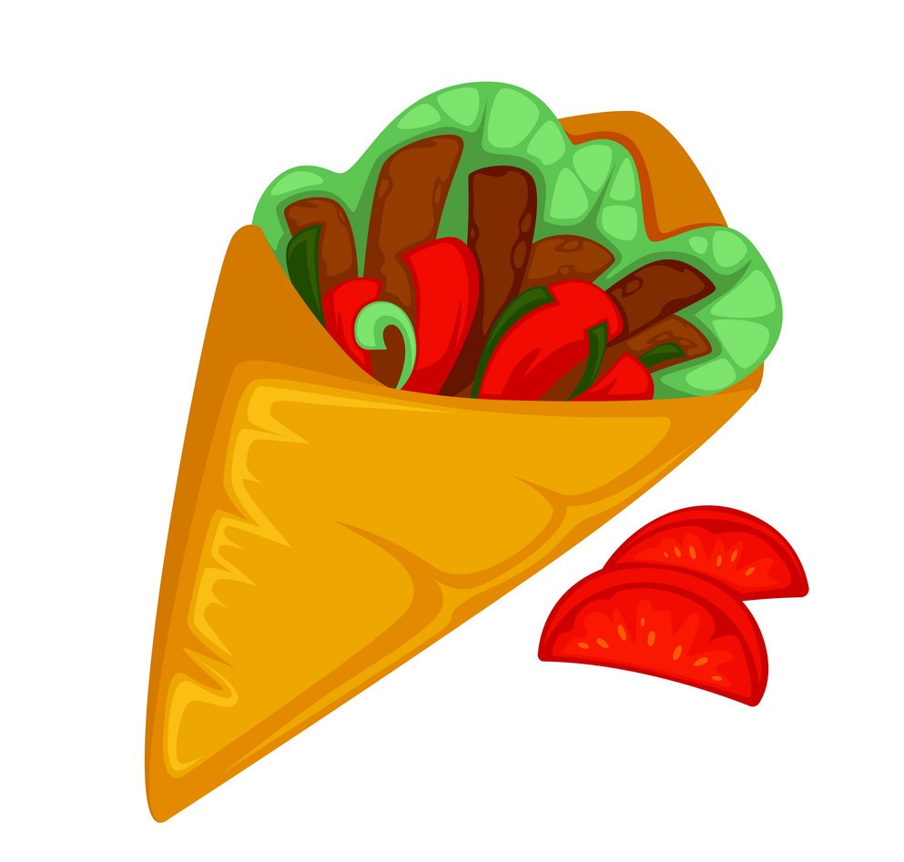

GYRO



BARBEQUE

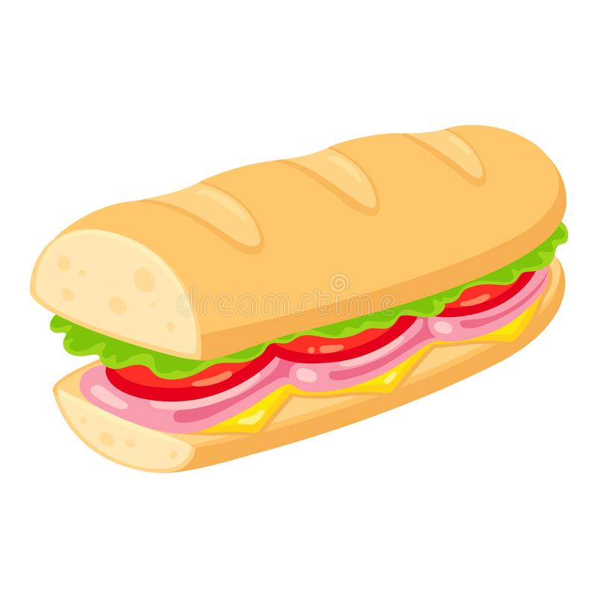

SANDWICH

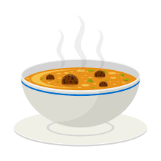

SOUP

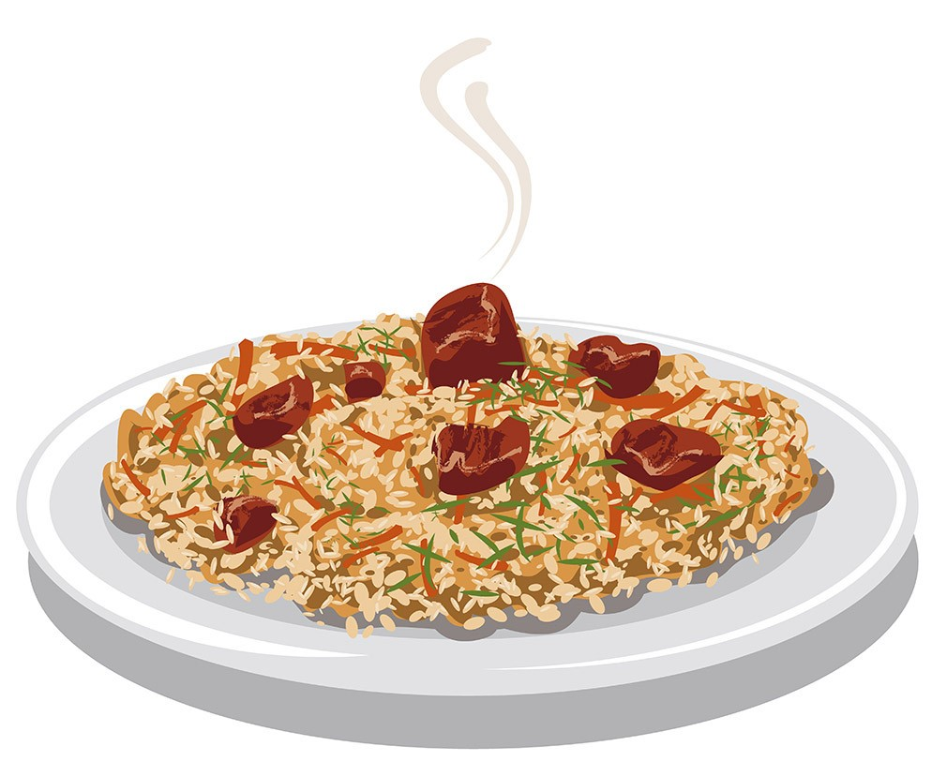

COMBO



PASTRY

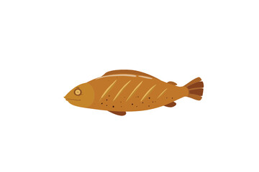

SEAFOOD



COFFEE

1. **Select from the following categories to filter search results (best if filters can be combined e.g. Breakfast + South):**
   * Nearest (default result)
   * West
   * East
   * South
   * Central
   * Breakfast
   * Brunch
   * Lunch
   * Dinner
   * Dine-in
   * Delivery
   * Halal
   * 24-Hour

**The following filter categories should be included but de-activated for now:**

* + Fine Dining
  + Eleat Special
  + Favourites
  + Kids Menu
  + PRIME
  + Tobago

1. **List of food items in the drop-down search box (with ability to add or change food categories as needed):**

* Appetizer
* Bacon
* Bake
* Bake & Shark
* Barbeque
* Beef
* Bread
* Burger
* Burrito
* Cake
* Callaloo
* Cheese
* Cheesecake
* Chicken
* Chinese
* Chocolate
* Chow
* Churro
* Cocktails
* Coffee
* Combo
* Cookie
* Corn
* Corn Soup
* Crab
* Creole
* Cupcake
* Curry
* Dessert
* Donut
* Doubles
* Eggs
* Fish
* Fries
* Fruit
* Grill
* Gyro
* Halal
* Hotdog
* Ice Cream
* Indian
* Italian
* Lamb
* Lasagne
* Lobster
* Mexican
* Milkshake
* Organic
* Pancakes
* Panini
* Pasta
* Pastry
* Pholourie
* Pie
* Pita
* Pizza
* Pork
* Potato
* Provision
* Quesadilla
* Ramen
* Ribs
* Rice
* Roti
* Salad
* Saltfish
* Samosa
* Sandwich
* Seafood
* Shrimp
* Smoothie
* Snack
* Soup
* Steak
* Stew
* Sushi
* Taco
* Tapas
* Tea
* Vegan
* Vegetable
* Vegetarian
* Waffles
* Wings
* Wonton
* Wrap